**4.3 Class Diagram**

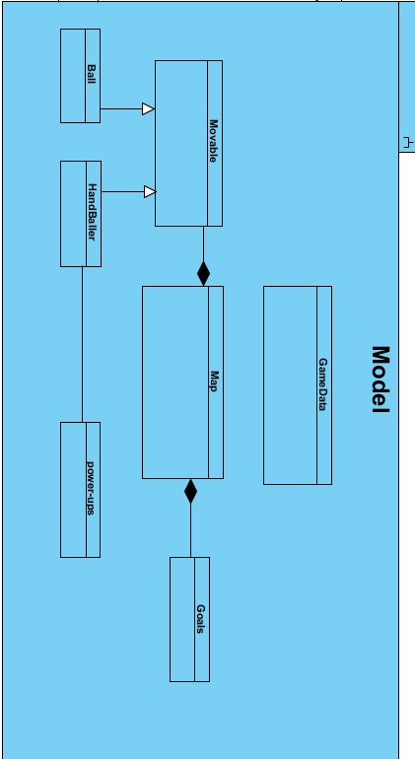

**4.2 Activity Diagram**

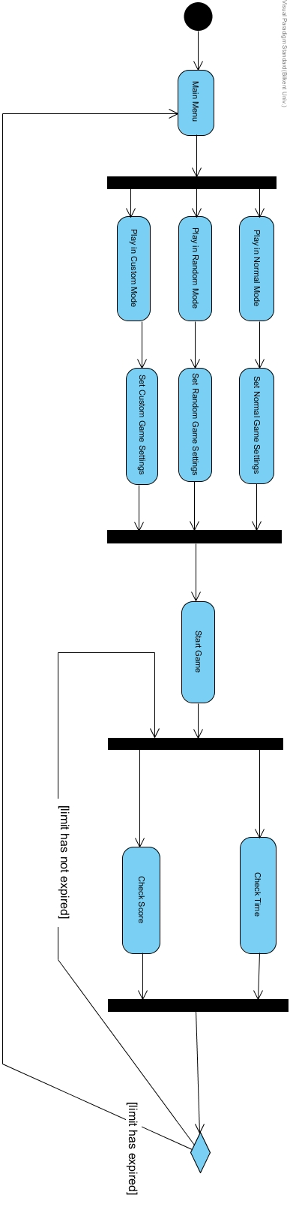

**4.1 Use Case Model**

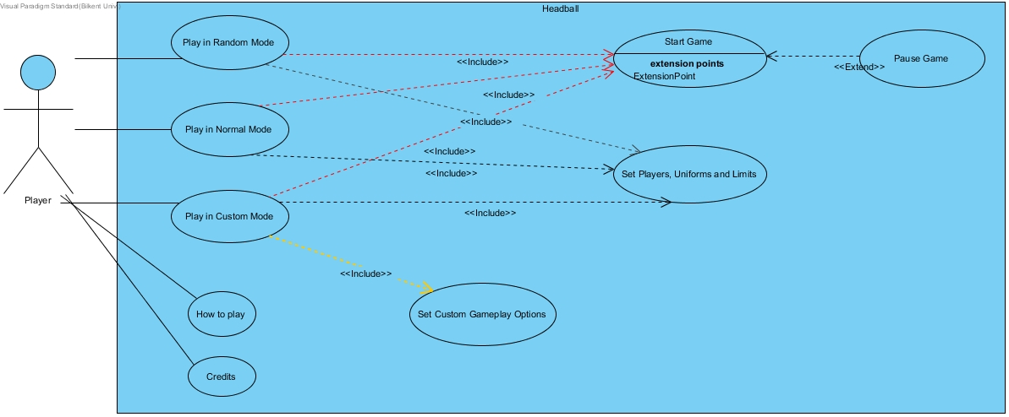

**4.4 Sequence Diagrams**

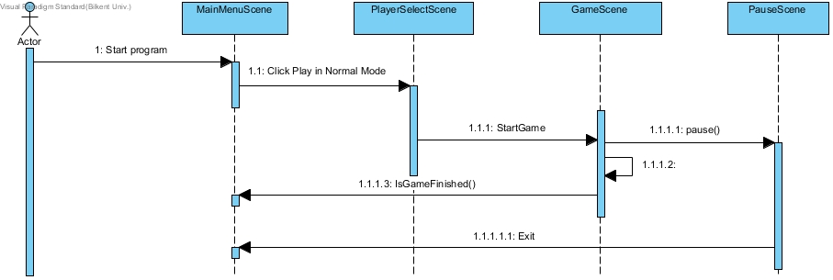

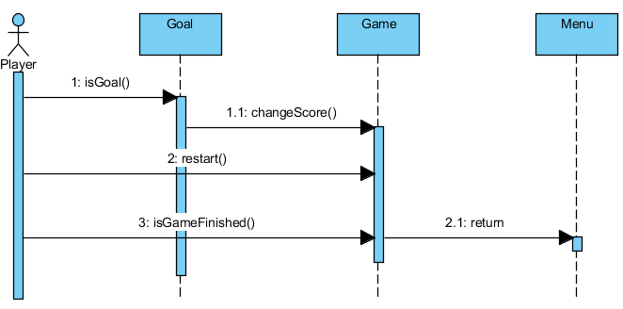

.

**4.5 State Diagram**

